- Purpose
  - The purpose of this document is to describe the procedure for assembling the Conductivity probes for the TDS Sensing system.
- Scope
  - This SOP applies to all equipment assembly team members. The process applies to the all Genesys machines with the SoliChem option
EP50282EQS0600BE1200 – Conductivity Sensor Assembly
- Responsibilities
  - The operations manager/supervisor is responsible for enforcing this SOP.
- Materials
  - The proper materials needed for this process are listed on the machine work order.
- Definitions

- Procedure
  - Cut a ¼” long piece of rubber tubing (E29020) and place it over the nose of the probe (E28774) as shown. It should cover the taper on the nose as shown.

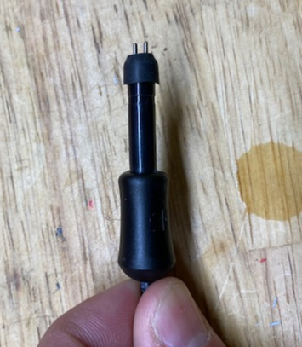

  - Take a t-fitting (E29315) and dip it into water for lubrication. Do not use soap. Press it over the probe and the hose with a twisting motion. Verify the probe is inserted as deep into the t-fitting as possible. The rubber hose should stay in place.

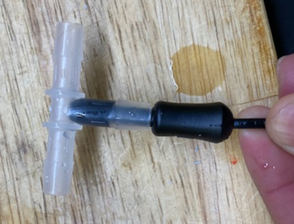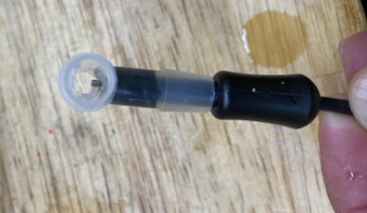
Hose should stay at the top
Should see the probes here

  - Cut a 1 ½” piece of shrink tubing (E28827) in place it over the probe and fitting. It needs to be fed from the cord end.

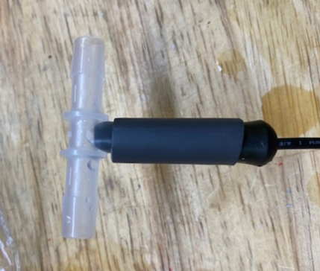

  - Use a heat gun to shrink the tubing and hold the assembly together. Use the heat gun (on lowest setting) until glue can be seen seeping out of both ends of the tubing. Ensure that it is even around both ends. Verify the probe is still present in the t-fitting.

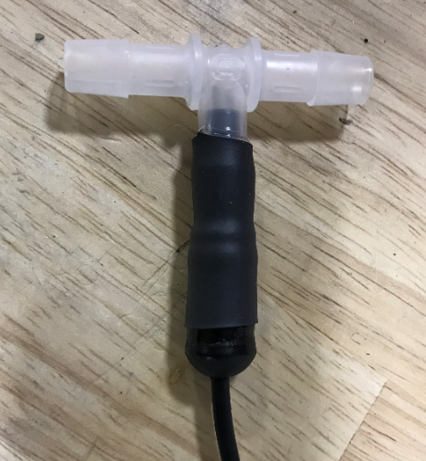

- References (optional section as needed)

- Training Guide

Functional Training Groups Requiring Training
Equipment Assembly Group

- SOP Change Control

Date of Change | Reason for Change
TBD | This is the first version of the S.O.P. hence there are no revisions to this document.
8/13/2021 | Added QC Checks
11/7/2023 | Updated to current process
3/31/2025 | Combined MSAS and G20 instructions
Approvals

Submitter/Author Approval:__________________________________ Date:______________________

Management Approval:______________________________________ Date:______________________

QAU Approval:_____________________________________________ Date:______________________

